**LAPORAN TUGAS PRAKTIKUM PEMROGRAMAN**

**S1- INFORMATIKA**

**“Pengenalan Object Oriented Programming”**

**Pertemuan ke : 1**

|  |  |
| --- | --- |
| **Nama** | Athiya Alif Gunawan |
| **NIM** | 19.11.3238 |
| **Dosen Pengampu** | Bayu Nadya Kusuma, S.T., M.Eng |
| **Nama Koordinator Asisten** | Dede Permana |
| **Kelas** | 18.S1 Informatika-10 |

**Program :**

Code Program

**File classMotor.cs**

using System;

using System.Collections.Generic;

using System.Text;

namespace MotorClasic {

class motor {

public string color = "green";

int transmissionState = 0;

Double speedMax = 250;

public Double currentSpeed = 0;

public void go() {

currentSpeed += 10;

}

public void turnLeft() {

currentSpeed -= 2;

}

}

}

Code Program

**File Program.cs**

using System;

namespace MotorClasic

{

class Program

{

static void Main(string[] args)

{

Console.WriteLine("Ini Adalah Motor Clasic Saya!");

motor Harley = new motor();

Console.WriteLine("Speed saat ini : " +Harley.currentSpeed);

Harley.go();

Console.WriteLine("Speed saat ini : " +Harley.currentSpeed);

Harley.turnLeft();

Console.WriteLine("Speed saat ini : " +Harley.currentSpeed);

Harley.go();

Console.WriteLine("Speed saat ini : " +Harley.currentSpeed);

Harley.turnLeft();

Console.WriteLine("Speed saat ini : " +Harley.currentSpeed);

}

}

}

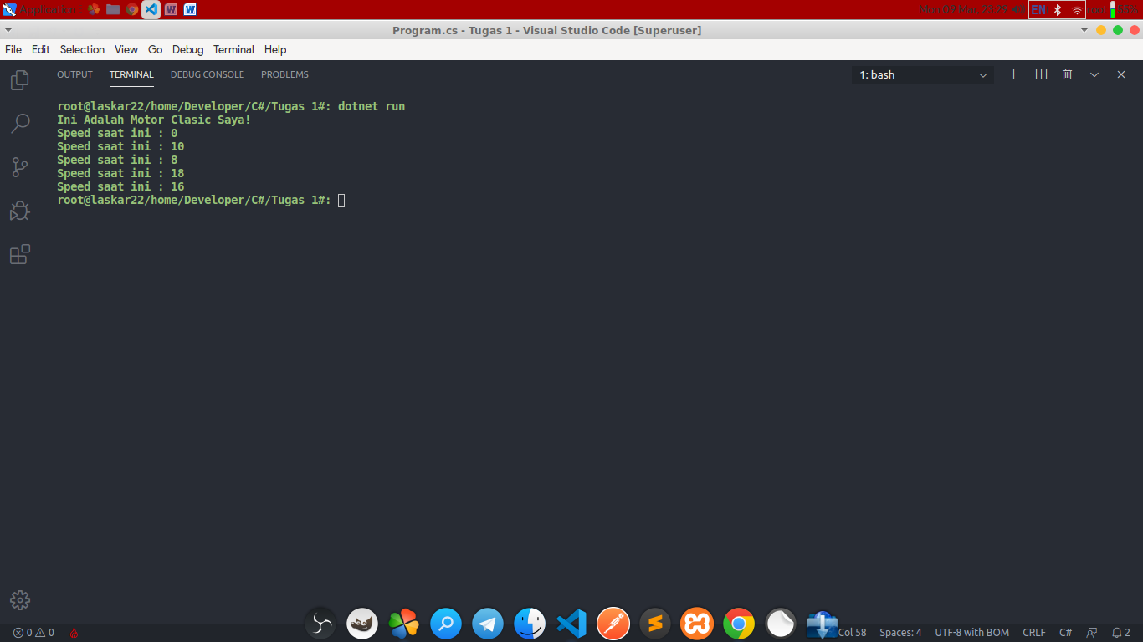Screenshoot Program Berjalane